Song Mood detection

Sai Samarth Taluri
Department Of Computer Science And Engineering
PES University
Bengaluru, India
saisamarth@gmail.com
Sanjana Mahesh
Department Of Computer Science And Engineering
PES University
Bengaluru, India
sanjanamahesh2002@gmail.com

Renita Kurian
Department Of Computer Science And Engineering
PES University
Bengaluru, India

rrenita1206@gmail.com

Abstract—We often want to listen to music that best fits our current emotion. A grasp of emotions in songs might be a great help for us to effectively discover music. Automated music mood recognition constitutes an active task in the field of MIR (Music Information Retrieval). In our project, we aim to provide an effective mechanism to classify music into various human emotions based on audio and the metadata. We will be using Mel-frequency cepstral coefficients (MFCCs) extracted from Mel spectrograms as attributes for training our CNN model. In order to extract the MFCC, we will be using Discrete Cosine Transform (DCT) as well as Fast Fourier Transform (FFT). Currently classification of music based on mood is manually done by selecting songs that belong to a particular mood and naming the playlist according to the mood, such as “relaxing”. Here we investigate the possibility of assigning such information automatically, without user interaction.
Keywords—mood, Song Lyrics, CNN, Russell’s Circumplex Model, MFCC

Introduction
In recent years, automatic playlist generation has been introduced to cope with the problem of the tedious and time consuming manual playlist selection.
Furthermore, browsing the entire music library manually to select songs for the playlist is felt to be difficult by most music listeners. This becomes especially difficult if music collections become prohibitively large, as the user will not know or remember all songs in it.

RELATED WORK

Data
Songs which are labelled according to Russell’s Circumplex Model will be used. Russell used a statistical technique to group the emotion ratings based on positive correlations – which gave rise to 4 major emotions that are “Happy”, “Angry” , “Sad” and “Relaxed”.
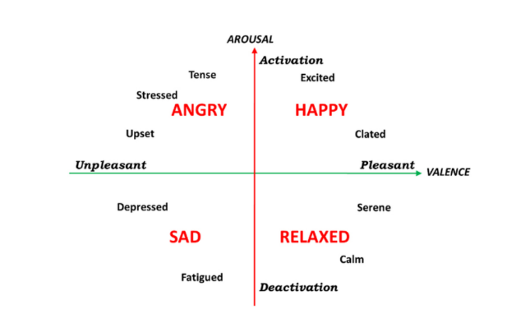

Additional Information
The songs in the dataset are of mp3 format which will be converted into a spectrogram using a popular audio analysis library known as “librosa”. Spectrogram is a visual representation of the spectrum of the frequencies of a signal as it varies with time.

METHOD

DataSet
The dataset consists of 1000 songs. They are categorized into 4 classes

Text Pre-processing
- Since our dataset contains no Null values , not much of pre=processing is required
- Feature extraction is the only pre-processing .we have to do
- The library “Libras” has predefined methods to do so
- Some of them include
- Zero Crossing Rate
- Spectral Centroids
- Mel-frequency cepstral coefficients
- Chromagram
- Mel-spectrogram
- Tonnetz

Implementation
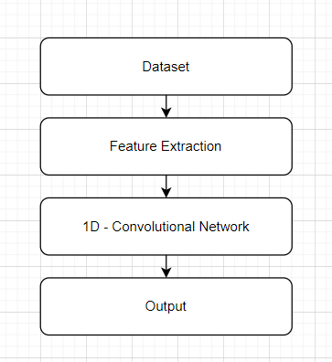.
Since the dataset already contains labels in the form of q1,q2,q3,q4 depending on the type of the music, and there are no null values, feature extraction is done. This is then split into test and train dataset in the ratio 80:20 and sent to the 1D-CNN model.
The model then returns the output in the form of text. The testing data is classified either as happy, angry ,sad or relaxed.
a  b    
Note that the equation is centered using a center tab stop. Be sure that the symbols in your equation have been defined before or immediately following the equation. Use “(1)”, not “Eq. (1)” or “equation (1)”, except at the beginning of a sentence: “Equation (1) is . . .”

Some Common Mistakes
- The word “data” is plural, not singular.
- The subscript for the permeability of vacuum μ₀, and other common scientific constants, is zero with subscript formatting, not a lowercase letter “o”.
- In American English, commas, semicolons, periods, question and exclamation marks are located within quotation marks only when a complete thought or name is cited, such as a title or full quotation. When quotation marks are used, instead of a bold or italic typeface, to highlight a word or phrase, punctuation should appear outside of the quotation marks. A parenthetical phrase or statement at the end of a sentence is punctuated outside of the closing parenthesis (like this). (A parenthetical sentence is punctuated within the parentheses.)
- A graph within a graph is an “inset”, not an “insert”. The word alternatively is preferred to the word “alternately” (unless you really mean something that alternates).
- Do not use the word “essentially” to mean “approximately” or “effectively”.
- In your paper title, if the words “that uses” can accurately replace the word “using”, capitalize the “u”; if not, keep using lower-cased.
- Be aware of the different meanings of the homophones “affect” and “effect”, “complement” and “compliment”, “discreet” and “discrete”, “principal” and “principle”.
- Do not confuse “imply” and “infer”.
- The prefix “non” is not a word; it should be joined to the word it modifies, usually without a hyphen.
- There is no period after the “et” in the Latin abbreviation “et al.”.
- The abbreviation “i.e.” means “that is”, and the abbreviation “e.g.” means “for example”.
An excellent style manual for science writers is [7].

RESULTS
After the text edit has been completed, the paper is ready for the template. Duplicate the template file by using the Save As command, and use the naming convention prescribed by your conference for the name of your paper. In this newly created file, highlight all of the contents and import your prepared text file. You are now ready to style your paper; use the scroll down window on the left of the MS Word Formatting toolbar.

Authors and Affiliations
The template is designed for, but not limited to, six authors. A minimum of one author is required for all conference articles. Author names should be listed starting from left to right and then moving down to the next line. This is the author sequence that will be used in future citations and by indexing services. Names should not be listed in columns nor group by affiliation. Please keep your affiliations as succinct as possible (for example, do not differentiate among departments of the same organization).

For papers with more than six authors: Add author names horizontally, moving to a third row if needed for more than 8 authors.

For papers with less than six authors: To change the default, adjust the template as follows.

Selection: Highlight all author and affiliation lines.

Change number of columns: Select the Columns icon from the MS Word Standard toolbar and then select the correct number of columns from the selection palette.

Deletion: Delete the author and affiliation lines for the extra authors.

Identify the Headings
Headings, or heads, are organizational devices that guide the reader through your paper. There are two types: component heads and text heads.
Component heads identify the different components of your paper and are not topically subordinate to each other. Examples include Acknowledgments and References and, for these, the correct style to use is “Heading 5”. Use “figure caption” for your Figure captions, and “table head” for your table title. Run-in heads, such as “Abstract”, will require you to apply a style (in this case, italic) in addition to the style provided by the drop down menu to differentiate the head from the text.
Text heads organize the topics on a relational, hierarchical basis. For example, the paper title is the primary text head because all subsequent material relates and elaborates on this one topic. If there are two or more sub-topics, the next level head (uppercase Roman numerals) should be used and, conversely, if there are not at least two sub-topics, then no subheads should be introduced. Styles named “Heading 1”, “Heading 2”, “Heading 3”, and “Heading 4” are prescribed.

Figures and Tables

Positioning Figures and Tables: Place figures and tables at the top and bottom of columns. Avoid placing them in the middle of columns. Large figures and tables may span across both columns. Figure captions should be below the figures; table heads should appear above the tables. Insert figures and tables after they are cited in the text. Use the abbreviation “Fig. 1”, even at the beginning of a sentence.
- Table Type Styles
Table Head | Table Column Head
Table Head | Table column subhead | Subhead | Subhead
copy | More table copyª
- Sample of a Table footnote. (Table footnote)
- Example of a figure caption. (figure caption)
Figure Labels: Use 8 point Times New Roman for Figure labels. Use words rather than symbols or abbreviations when writing Figure axis labels to avoid confusing the reader. As an example, write the quantity “Magnetization”, or “Magnetization, M”, not just “M”. If including units in the label, present them within parentheses. Do not label axes only with units. In the example, write “Magnetization (A/m)” or “Magnetization {A[m(1)]}”, not just “A/m”. Do not label axes with a ratio of quantities and units. For example, write “Temperature (K)”, not “Temperature/K”.

Acknowledgment
We would like to thank our instructor from the department of computer science at PES University, India. In addition, we would like to thank the university for providing us with an opportunity to complete this project.

References
Some of the papers we used for reference are mentioned below
- MOOD CLASSIFICATION USING LISTENING DATA By Filip Korzeniowski, Oriol
- TRANSFER LEARNING FOR MUSIC CLASSIFICATION AND REGRESSION
- EMOTION BASED SEGMENTATION OF MUSICAL AUDIO By Anna Aljanaki,

